**RECITATION PROBLEMS**

Exercise 9.2.1: Three computers, A, B, and C, have the numerical features listed below:

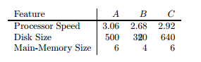

We may imagine these values as defining a vector for each computer; for instance, A’s vector is [3.06, 500, 6]. We can compute the cosine distance between any two of the vectors, but if we do not scale the components, then the disk size will dominate and make differences in the other components essentially invisible. Let us use 1 as the scale factor for processor speed, α for the disk size, and β for the main memory size.

1. In terms of α and β, compute the cosines of the angles between the vectors for each pair of the three computers.

**Answer:**

1. cos(A,B)=8.2008 + 160000𝛼2 + 24𝛽2 / √9.3636 + 250000𝛼2 + 36𝛽2 √7.1824 + 102400𝛼2 + 16𝛽2
2. cos(B,C)= 7.8256 + 204800𝛼2 + 24𝛽2 / √7.1824 + 102400𝛼2 + 16𝛽2

√8.5264 + 409600𝛼2 + 36𝛽2

1. cos(A,C) =8.9352 + 320000𝛼2 + 36𝛽2 / √9.3636 + 250000𝛼2 + 36𝛽2 √8.5264 + 409600𝛼2 + 36𝛽2
2. What are the angles between the vectors if α = β = 1?

**Answer:**

1. Cosine of the angle between A[3.06 500α 6β]and B[2.68 320α 4β]

= 3.06*2.68+ 500α* 320α+ 6β* 4β/ √3.06^2+500α^2+6β^2 * √ 2.68^2+320α^2+4β^2

= 8.2008 + 160000α^2 +24β^2/ √9.3636 +250000α^2+36β^2 * √ 7.1824 +102400α^2 +16β^2

=8.2008 + 160000*1^2 +24*1^2/ √9.3636 +250000*1^2+36*1^2 * √ 7.1824 +102400*1^2 +16*1^2

= 0.99999733

Theta

=cos-1(0.99999733)

= 0.132

1. Cosine of the angle between B[2.68 320α 4β] and C [ 2.92 640α 6β]

= 7.8256+204800α^2+24β^2/ √ 7.1824 +102400α^2 +16β^2 * √8.5264+409600α^2+36β^2

= 7.8256+204800*1^2+24*1^2/ √ 7.1824 +102400*1^2 +16*1^2 * √8.5264+409600*1^2+36*1^2

Theta

=cos-1 (0.99998785)

= 0.282

1. Cosine of the angle between A[3.06 500α 6β] and C [ 2.92 640α 6β]

= 8.9352+ 320000α^2+ 36β^2/√9.3636 +250000α^2+36β^2 * √8.5264+409600α^2+36β^2

= 8.9352+ 320000*1^2+ 36*1^2/√9.3636 +250000*1^2+36*1^2 * √8.5264+409600*1^2+36*1^2

Theta

=cos-1 (0.99999534)

= 0.175

1. What are the angles between the vectors if α = 0.01 and β = 0.5?

**Answer:**

1. Cosine of the angle between A[3.06 500α 6β]and B[2.68 320α 4β]

= 3.06*2.68+ 500α* 320α+ 6β* 4β/ √3.06^2+500α^2+6β^2 * √ 2.68^2+320α^2+4β^2

= 8.2008 + 160000*0.01^2 +24*0.5^2/ √9.3636 +250000*0.01^2+36*0.5^2 * √ 7.1824 +102400*0.01^2 +16*0.5^2

Theta

=cos-1 (0.9908815)

=7.74

1. Cosine of the angle between A[3.06 500α 6β] and C [ 2.92 640α 6β]

= 8.9352+ 320000*α^2+ 36β^2/√9.3636 +250000α^2+36β^2 * √8.5264+409600α^2+36β^2

= 8.9352+ 320000*0.01^2+ 36*0.5^2/√9.3636 +250000*0.01^2+36*0.5^2 * √8.5264+409600*0.01^2+36*0.5^2

Theta

=cos-1 ( 0.99155471)

= 7.

1. Cosine of the angle between B[2.68 320α 4β] and C [ 2.92 640α 6β]

= 7.8256+204800α^2+24β^2/ √ 7.1824 +102400α^2 +16β^2 * √8.5264+409600α^2+36β^2

= 7.8256+204800*0.01^2+24*0.5^2/ √ 7.1824 +102400*0.01^2 +16*0.5^2 * √8.5264+409600*0.01^2+36*0.5^2

Theta

= cos-1 (0.96917792)

= 14.26

1. One fair way of selecting scale factors is to make each inversely proportional to the average value in its component. What would be the values of α and β, and what would be the angles between the vectors?

**Answer:**

|  |  |  |  |  |
| --- | --- | --- | --- | --- |
| Feature | A | B | C | Average of Compnents |
| Processor Speed | 3.06 | 2.68 | 2.92 | 2.88 |
| Disk Size | 500 | 320 | 640 | 486.67 |
| Main Memory size | 6 | 4 | 6 | 5.33 |

Scale factor for processor speed =1/2.88 = 0.347

Scale factor for Disk size, α=1/486.67 = 0.002

Scale factor for Main memory size, β =1/5.33 = 0.187

|  |  |  |  |
| --- | --- | --- | --- |
| Feature | A | B | C |
| Processor Speed | 1.06 | 0.93 | 1.01 |
| Disk Size | 1 | 0.64 | 1.28 |
| Main Memory size | 1.12 | 0.75 | 1.12 |

Cosine of the angle between A[1.06 1 1.12]and B[0.93 0.64 0.75]

= 1.06*0.93+ 1*0.64+ 1.12*0.75/ √1.06^2+1^2+1.12^2 *√0.93^2+0.64^2+0.75^2

Theta

= cos-1 (0.9898)

=8.19

Cosine of the angle between A[1.06 1 1.12] and C [1.01 1.28 1.12]

= 1.06*1.01+ 1*1.28+ 1.12*1.12/√1.06^2+1^2+1.12^2 * √1.01^2+1.28^2+1.12^2

Theta

=cos-1 ( 0.9915)

= 7.475

Cosine of the angle between B[0.93 0.64 0.75] and C [1.01 1.28 1.12]

= 0.93*1.01+0.64*1.28+0.75*1.12/√ 0.93^2+0.64^2+0.75^2 * √1.01^2+1.28^2+1.12^2

Theta

=cos-1 (0.9692)

= 14.257

Exercise 9.2.3: A certain user has rated the three computers of Exercise 9.2.1 as follows: A: 4 stars, B: 2 stars, C: 5 stars.

1. Normalize the ratings for this user.

**Answer:**

avg = (4+2+5)/3=11/3

A: 4-11/3=1/3

B: 2-11/3=-5/3

C: 5-11/3=4/3

1. Compute a user profile for the user, with components for processor speed, disk size, and main memory size, based on the data of Exercise 9.2.1.

**Answer:**

Processor Speed: 3.06*1/3-2.68*5/3+2.92*4/3= 0.4467

Disk Size: 500*1/3-320*5/3+640*4/3= 486.6667

Main-Memory Size: 6*1/3-4*5/3+6*4/3= 3.3333

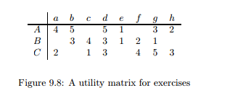

Exercise 9.3.1: Figure 9.8 is a utility matrix, representing the ratings, on a 1–5 star scale, of eight items, a through h, by three users A, B, and C. Compute the following from the data of this matrix.

1. Treating the utility matrix as boolean, compute the Jaccard distance between each pair of users.

**Answer:** Jaccard(A,B)=4/8=0.5

Distance = 0.5

Jaccard(B, C) = 4/8 = 0.5

Distance = 0.5

Jaccard(A, C) = 4/8 = 0.5

Distance = 0.5

(b) Repeat Part (a), but use the cosine distance.

**Answer:** cos(A, B) = 17 20√2 = 0.601

Distance = 0.399

cos(B, C) = 11 8√10 = 0.5138

Distance = 0.4862

cos(A, C) = 11 8√5 = 0.615

Distance = 0.385

(c) Treat ratings of 3, 4, and 5 as 1 and 1, 2, and blank as 0. Compute the Jaccard distance between each pair of users.

**Answer:**

|  |  |  |  |  |  |  |  |  |
| --- | --- | --- | --- | --- | --- | --- | --- | --- |
|  | a | b | c | d | e | f | g | h |
| A | 1 | 1 | 0 | 1 | 0 | 0 | 1 | 0 |
| B | 0 | 1 | 1 | 1 | 0 | 0 | 0 | 0 |
| C | 0 | 0 | 0 | 1 | 0 | 1 | 1 | 1 |

Jaccard Similarity = M11/(M01+M10+M11)

Jaccard Distance = (M10+ M01)/(M01+M10+M11) = 1-J

Jaccard Similiarity between A and B = 2/5 = 0.4

Jaccard Distance = 0.6

Jaccard Similiarity between A and C = 2/6 = 0.3333

Jaccard Distance = 0.666667

Jaccard Similiarity between B and C = 1/6 = 0.1666

Jaccard Distance = 0.833334

(d) Repeat Part (c), but use the cosine distance.

**Answer:**

Cosine Similarity between A and B = 0.5774

Hence, distance: 1-|0.577| = 0.4226

Cosine Similarity between A and C = 0.5

Hence, distance: 1-|0.25| = 0.5

Cosine Similarity between B and C = 0.2887

Hence, distance: 1-|0.2887| = 0.7113

(e) Normalize the matrix by subtracting from each non blank entry the average value for its user.

**Answer:**

Normalizing

|  |  |  |  |  |  |  |  |  |
| --- | --- | --- | --- | --- | --- | --- | --- | --- |
|  | a | b | c | d | e | f | g | h |
| A | 0.66 | 1.66 | - | 1.66 | 1 | - | -0.34 | -1.34 |
| B | - | 0.66 | 1.66 | 0.66 | -1.34 | -0.34 | -1.34 | - |
| C | -1 |  | -2 | 0 | - | 1 | 2 | 0 |

(f) Using the normalized matrix from Part (e), compute the cosine distance between each pair of users.

**Answer:**

Cosine similarity between A and B = 0.584

Hence, distance: 1-|0.584| = 0.416

Cosine similarity between A and C = -0.1154

Hence, distance: 1-|0.1154| =0.8846

Cosine similarity between B and C = -0.74

Hence, distance: 1-|0.74| = 0.260

Exercise 9.4.1: Starting with the decomposition of Fig. 9.10, we may choose any of the 20 entries in U or V to optimize first. Perform this first optimization step assuming we choose:

(a) u32

**Answer:**

Start with the U and V in Fig. 9.10

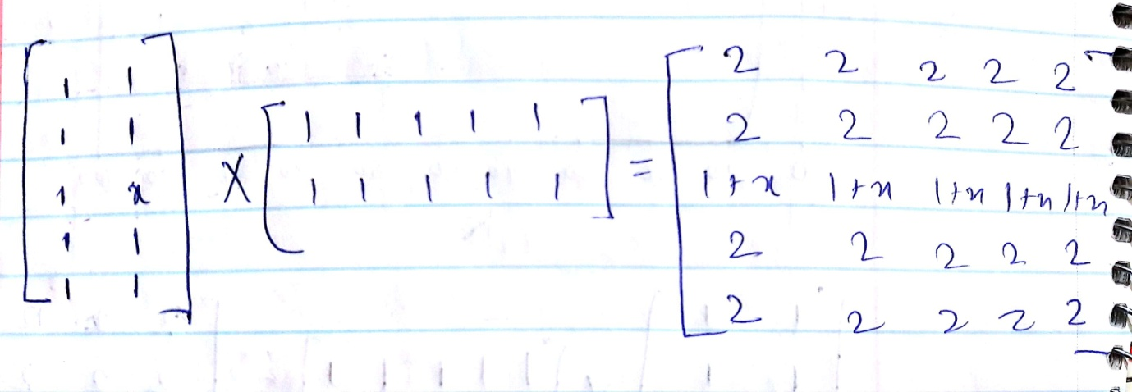

The contribution to the sum of squares from the third row is(x − 1)2 + (𝑥 − 2)2 + 𝑥2 + (𝑥 − 3)2

We find the minimum value of this expression by differentiating and equating to 0, as:2 × ((x − 1) + (x − 2) + x + (x − 3)) = 0

The solution for x is x = 1.5

Thus after the first step

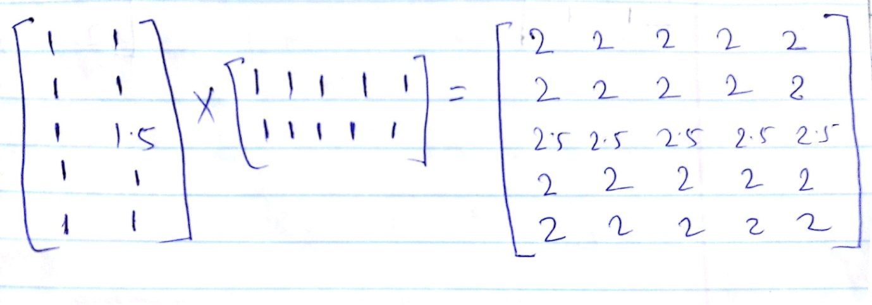

(b) v41.

**Answer:**

Start with the U and V in Fig. 9.10

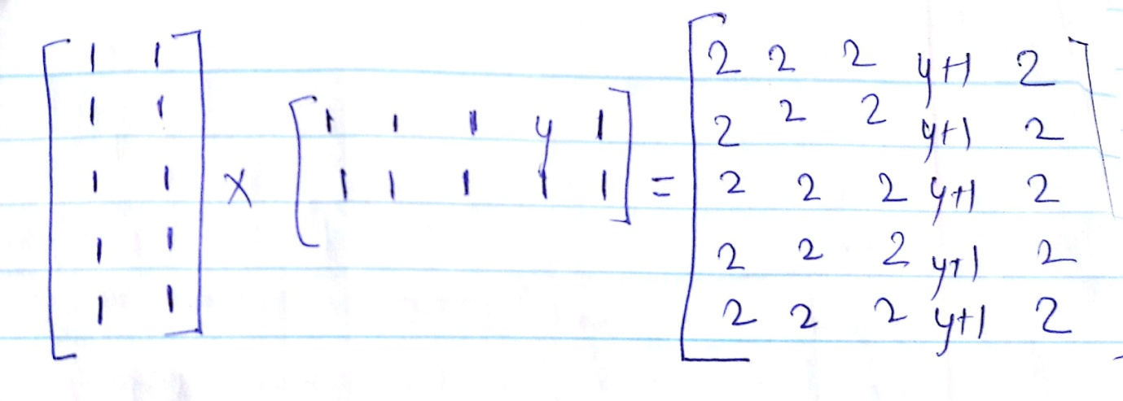

The contribution to the sum of squares from the forth column is

(y − 3)2 + (𝑦 − 3)2 + 𝑦2 + (𝑦 − 2)2 + (𝑦 − 3)2

We find the minimum value of this expression by differentiating and equating to 0, as: 2 × ((y − 3) + (y − 3) + y + (y − 2) + (y − 3)) = 0

The solution for x is y=2.2

Thus after the first step

